THE FIRST GOVERNMENT FALLS BECAUSE OF FOOD AND FUEL SHORTAGES

The first government has fallen due to food and fuel shortages due to the pandemic, war in Ukraine and climate change. I had a blog teed up a month ago about the first food riots in Sri Lanka. People were waiting in lines kilometers long for food and fuel. Then climate extremes hit and I put it on hold. Now the government has fallen! The Arab spring occurred after food shortages due to the economic crash of 2008. How many governments will change as people riot due to the high costs and shortages of food?

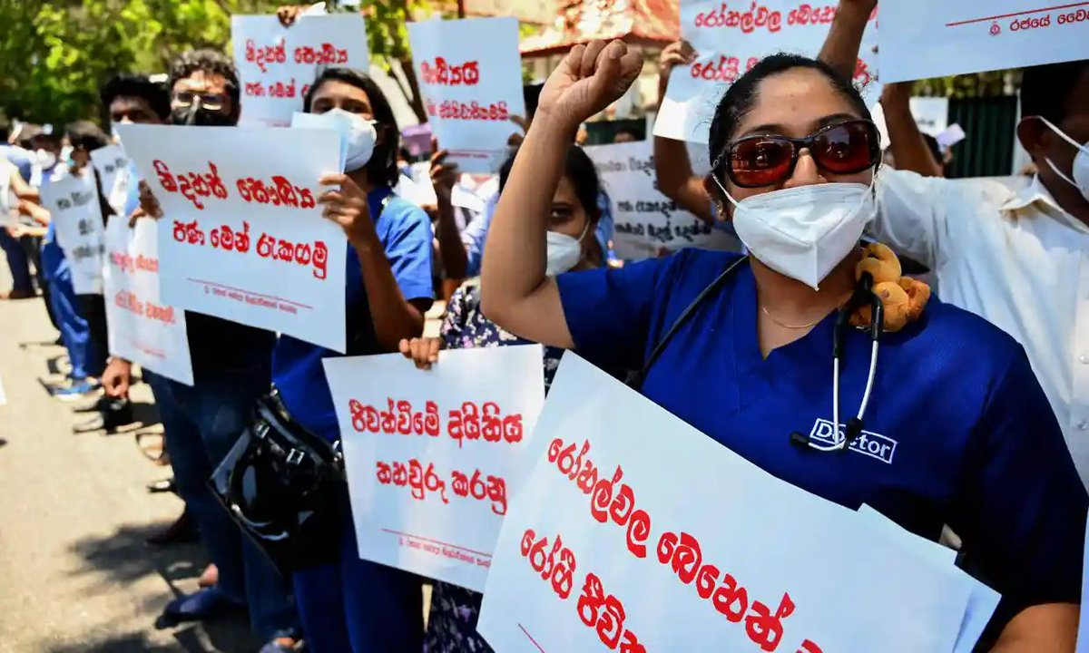

In Sri Lanka, people stood in lines kilometers long to get food and fuel.

Drought and reduced water supplies resulted in 395,000 acres of cropland left dry and unplanted. Portugal and Spain have experienced the worst drought in 15 years. While Germany, Belgium and other EU countries were hit by heavy rainfall and severe flooding which destroyed harvests and grain stocks.

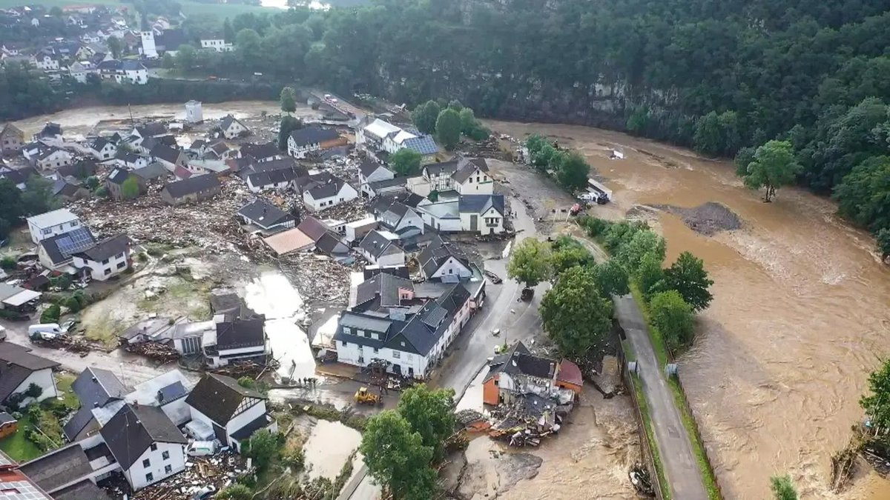

German city and surrounding countryside deluged with rain and flooding. Crops were destroyed and grain stores washed away or soaked and ruined.

We need to build food resilience. We already have 2 billion people who are food insecure. How are people in low- and middle-income countries going to deal with rising prices, heat that makes work and income impossible. Where will these people go for food, for refuge? How many people are we going to allow to be malnourished before the rest of us care?

